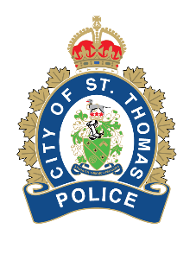 | St. Thomas Police Service  BOARD POLICY

Subject: | Undercover Operations
Policy Number: | LE – 057
Effective Date: | April 1, 2024
Reviewed: | April 22, 2026
Authorized: | Police Services Board
AUTHORITY/LEGISLATIVE REFERENCE
- Community Safety and Policing Act, 2019 S.O. 2019, c. 1, Sched. 1
- Ontario Regulation 392/23 – Adequate and Effective Policing (General)
POLICY STATEMENT
The St. Thomas Police Services Board is committed to ensuring the safety of police officers and the public while maintaining integrity, accountability and legal compliance in all aspects of police work.
The Board recognizes that undercover operations may be necessary in support of criminal investigations and intelligence-led policing, but that such operations involve heightened legal, operational and safety risks and must therefore be governed by clear procedures and oversight.
POLICY APPLICATION
It is the policy of the Board with respect to undercover operations, that the Chief of Police shall:
- establish written procedures for conducting undercover operations in compliance with the Community Safety and Policing Act, its regulations, and applicable legal standards;
- ensure that all written procedures prioritize officer and public safety, maintain the integrity of investigations, and ensure accountability; and
- ensure that all written procedures are regularly reviewed and updated to align with legislative changes and operational needs.

